SEMH Conference
Enabling and Empowering Wellbeing:
Understanding and Supporting Traumatic Need

Ambitions Teaching School
12th March 2020
13:30 – 16:30
Venue: The Factory, 14 Alder Hills, Poole BH12 4AS
Cost: £15.00

Audience
Teachers / HLTAs and SENDCOs: practitioners with an understanding of how to support SEND, looking to develop skills, strategies and ideas when working with pupils who present with SEMH / Associated Need

Content
Welcome and brief scene setting: James Franzen
KEY NOTE SPEAKER: Ian Hunkin – The Transformative Power of Feeling Safe

Followed by, a choice of 2 x 45 minute workshops from the following (between 14:30 and 16:15):
Workshop 3  Trauma Informed Practice  Rachel Thynne – SEMH Outreach Team  - Practice in the Classroom  - A curious ‘WIN’ approach | Workshop 2  Social and Emotional Skills – Progression  Catherine Walker  - Assessing and Teaching Social and Emotional Skills
Workshop 1
PACE+
Ian Hunkin

- Key learning to support trauma
- Overcoming blocked trust

4:15pm – Summary / Conclusion / Next Steps
For further information, please contact: Sophie Bennett – Sophie.bennett@queenspark-academy.co.uk
Book places on www.cpdportal-sw.org or via the email address above
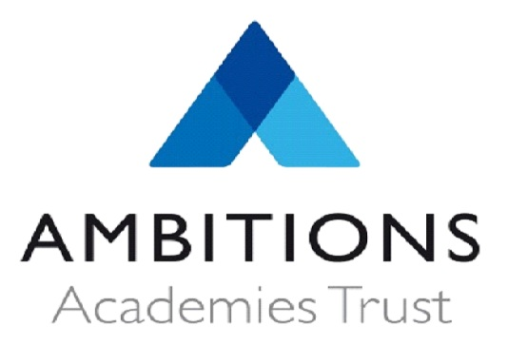01202 526079 or visit our website www.ambitions-teachingschool.co.uk

